IDF1/2

1. **Punto a - Conexión => OK**

#Las placas de red de las PC a los switches.

- Las pcs se conectan a los routers/switches a partir de la primera boca Ethernet

- Cable directo

#Conexión entre Routers.

- Se realiza con cable cruzado (linea negra punteada).

- Se empieza desde el último puerto disponible.

# La conexión entre el puerto RS232 a la consola del router.

- Cable celeste, se une RS232 <=>Consola

1. **Configurar los switchs**

Ingresar a la terminal nada más.

1. **Modos de la CLI Interfaz**

1-Configurar el prompt: Que sería el nombre del switch

Switch>Enable

Switch#COnfigure terminal

Enter configuration commands, one per line. End with CNTL/Z.

Switch(config)#hostName SW1

…

Switch(config)#hostName SW2

2- Ingresar los comandos:

*# SW2>?*

Exec commands:

connect Open a terminal connection

disable Turn off privileged commands

disconnect Disconnect an existing network connection

enable Turn on privileged commands

exit Exit from the EXEC

logout Exit from the EXEC

ping Send echo messages

resume Resume an active network connection

show Show running system information

telnet Open a telnet connection

terminal Set terminal line parameters

traceroute Trace route to destination

3- Ingresar los comandos:

# SW2>show ?

arp Arp table

cdp CDP information

clock Display the system clock

crypto Encryption module

dtp DTP information

etherchannel EtherChannel information

flash: display information about flash: file system

history Display the session command history

interfaces Interface status and configuration

ip IP information

ipv6 IPv6 information

mac MAC configuration

mac-address-table MAC forwarding table

mls Show MultiLayer Switching information

privilege Show current privilege level

sessions Information about Telnet connections

ssh Status of SSH server connections

tcp Status of TCP connections

terminal Display terminal configuration parameters

users Display information about terminal lines

version System hardware and software status

vlan VTP VLAN status

vtp VTP information

4

SW2>enable

5

SW2#show ?

access-lists List access lists

arp Arp table

boot show boot attributes

cdp CDP information

clock Display the system clock

crypto Encryption module

dtp DTP information

etherchannel EtherChannel information

flash: display information about flash: file system

history Display the session command history

hosts IP domain-name, lookup style, nameservers, and host table

interfaces Interface status and configuration

ip IP information

ipv6 IPv6 information

logging Show the contents of logging buffers

mac MAC configuration

mac-address-table MAC forwarding table

mls Show MultiLayer Switching information

port-security Show secure port information

privilege Show current privilege level

processes Active process statistics

running-config Current operating configuration

sessions Information about Telnet connections

snmp snmp statistics

spanning-tree Spanning tree topology

ssh Status of SSH server connections

startup-config Contents of startup configuration

storm-control Show storm control configuration

tcp Status of TCP connections

tech-support Show system information for Tech-Support

terminal Display terminal configuration parameters

users Display information about terminal lines

version System hardware and software status

vlan VTP VLAN status

vtp VTP information

6

SW2#enable

SW2# show running-config

Building configuration...

Current configuration : 989 bytes

!

version 12.1

no service timestamps log datetime msec

no service timestamps debug datetime msec

no service password-encryption

!

hostname SW2

!

!

!

spanning-tree mode pvst

!

interface FastEthernet0/1

!

interface FastEthernet0/2

!

interface FastEthernet0/3

Segundo comando …

SW2#show startup-config

Using 962 bytes

!

version 12.1

no service timestamps log datetime msec

no service timestamps debug datetime msec

no service password-encryption

!

hostname Switch

!

!

!

interface FastEthernet0/1

!

interface FastEthernet0/2

!

interface FastEthernet0/3

!

interface FastEthernet0/4

!

interface FastEthernet0/5

!

interface FastEthernet0/6

--More--

7

SW2#show interface

FastEthernet0/1 is up, line protocol is up (connected)

Hardware is Lance, address is 00d0.975b.d801 (bia 00d0.975b.d801)

BW 100000 Kbit, DLY 1000 usec,

reliability 255/255, txload 1/255, rxload 1/255

Encapsulation ARPA, loopback not set

Keepalive set (10 sec)

Full-duplex, 100Mb/s

input flow-control is off, output flow-control is off

ARP type: ARPA, ARP Timeout 04:00:00

Last input 00:00:08, output 00:00:05, output hang never

Last clearing of "show interface" counters never

Input queue: 0/75/0/0 (size/max/drops/flushes); Total output drops: 0

Queueing strategy: fifo

Output queue :0/40 (size/max)

5 minute input rate 0 bits/sec, 0 packets/sec

5 minute output rate 0 bits/sec, 0 packets/sec

956 packets input, 193351 bytes, 0 no buffer

Received 956 broadcasts, 0 runts, 0 giants, 0 throttles

0 input errors, 0 CRC, 0 frame, 0 overrun, 0 ignored, 0 abort

0 watchdog, 0 multicast, 0 pause input

0 input packets with dribble condition detected

2357 packets output, 263570 bytes, 0 underruns

Identifique información de las capas 1 y 2 OSI.

8

SW2#configure terminal

Enter configuration commands, one per line. End with CNTL/Z.

SW2(config)#

-- 9 –

SW2(config)#?

Configure commands:

access-list Add an access list entry

banner Define a login banner

boot Boot Commands

cdp Global CDP configuration subcommands

clock Configure time-of-day clock

crypto Encryption module

do To run exec commands in config mode

enable Modify enable password parameters

end Exit from configure mode

exit Exit from configure mode

hostname Set system's network name

interface Select an interface to configure

ip Global IP configuration subcommands

line Configure a terminal line

logging Modify message logging facilities

mac MAC configuration

mac-address-table Configure the MAC address table

no Negate a command or set its defaults

port-channel EtherChannel configuration

privilege Command privilege parameters

service Modify use of network based services

snmp-server Modify SNMP engine parameters

spanning-tree Spanning Tree Subsystem

username Establish User Name Authentication

vlan Vlan commands

vtp Configure global VTP state

10 y 11

SW1>enable

SW1#configure terminal

Enter configuration commands, one per line. End with CNTL/Z.

SW1(config)#hostname switch-100

switch-100(config)#enable secret utn

-- 12 --

switch-100# show running-config

Building configuration...

Current configuration : 1045 bytes

!

version 12.1

no service timestamps log datetime msec

no service timestamps debug datetime msec

no service password-encryption

!

hostname switch-100

!

enable secret 5 $1$mERr$og3fU2Zrm1u/R/oQwVr8H/

!

!

!

spanning-tree mode pvst

!

interface FastEthernet0/1

!

interface FastEthernet0/2

!

interface FastEthernet0/3

-- 13 –

switch-100# copy running-config star

Destination filename [startup-config]?

Building configuration...

[OK]

switch-100#

si apretó TAB

switch-100# copy running-config startup-config

Destination filename [startup-config]?

Building configuration...

[OK]

switch-100#

1. **Adminsitración remota**

Poner en el Switch: Line vty 0 1 “para habilitar dos líneas remotas de administración”

switch-100#

switch-100#conf t

Enter configuration commands, one per line. End with CNTL/Z.

switch-100(config)#

switch-100(config)#line vty 0 1

switch-100(config-line)#password clase

switch-100(config-line)#login

switch-100(config-line)#^Z

Ahora intento administrar el switch desde la termina 102

PC>telnet 192.168.1.100

Trying 192.168.1.100 ...Open

User Access Verification

Password: “clase”

switch-100>enable

Password: “utn”

switch-100#config t

Enter configuration commands, one per line. End with CNTL/Z.

switch-100(config)#

1. **Configuración de interfaces**

1

switch-100(config)#interface f 0/1

switch-100(config-if)#

2

switch-100(config-if)#?

cdp Global CDP configuration subcommands

channel-group Etherchannel/port bundling configuration

channel-protocol Select the channel protocol (LACP, PAgP)

description Interface specific description

duplex Configure duplex operation.

exit Exit from interface configuration mode

ip Interface Internet Protocol config commands

mls mls interface commands

no Negate a command or set its defaults

shutdown Shutdown the selected interface

spanning-tree Spanning Tree Subsystem

speed Configure speed operation.

storm-control storm configuration

switchport Set switching mode characteristics

tx-ring-limit Configure PA level transmit ring limit

-

switch-100(config-if)#

%LINK-5-CHANGED: Interface FastEthernet0/1, changed state to administratively down

%LINEPROTO-5-UPDOWN: Line protocol on Interface FastEthernet0/1, changed state to down

-

switch-100(config-if)#no shutdown

switch-100(config-if)#

%LINK-5-CHANGED: Interface FastEthernet0/1, changed state to up

%LINEPROTO-5-UPDOWN: Line protocol on Interface FastEthernet0/1, changed state to up

Apago todas las interfaces y solamente dejo de la 1 a la 5 activas

switch-100(config)#interface range f0/1-10

switch-100(config-if-range)#shutdown

%LINK-5-CHANGED: Interface FastEthernet0/3, changed state to administratively down

%LINK-5-CHANGED: Interface FastEthernet0/4, changed state to administratively down

%LINK-5-CHANGED: Interface FastEthernet0/5, changed state to administratively down

%LINK-5-CHANGED: Interface FastEthernet0/6, changed state to administratively down

%LINK-5-CHANGED: Interface FastEthernet0/7, changed state to administratively down

%LINK-5-CHANGED: Interface FastEthernet0/8, changed state to administratively down

%LINK-5-CHANGED: Interface FastEthernet0/9, changed state to administratively down

%LINK-5-CHANGED: Interface FastEthernet0/10, changed state to administratively down

switch-100(config-if-range)#

%LINK-5-CHANGED: Interface FastEthernet0/1, changed state to administratively down

%LINEPROTO-5-UPDOWN: Line protocol on Interface FastEthernet0/1, changed state to down

%LINK-5-CHANGED: Interface FastEthernet0/2, changed state to administratively down

%LINEPROTO-5-UPDOWN: Line protocol on Interface FastEthernet0/2, changed state to down

switch-100(config-if-range)#exit

switch-100(config)#interface range f0/1-5

switch-100(config-if-range)#no shutdown

%LINK-5-CHANGED: Interface FastEthernet0/3, changed state to down

%LINK-5-CHANGED: Interface FastEthernet0/4, changed state to down

%LINK-5-CHANGED: Interface FastEthernet0/5, changed state to down

switch-100(config-if-range)#

%LINK-5-CHANGED: Interface FastEthernet0/2, changed state to up

%LINEPROTO-5-UPDOWN: Line protocol on Interface FastEthernet0/2, changed state to up

4

switch-100#show running-config

Building configuration...

Current configuration : 1131 bytes

!

version 12.1

no service timestamps log datetime msec

no service timestamps debug datetime msec

no service password-encryption

!

hostname switch-100

!

enable secret 5 $1$mERr$og3fU2Zrm1u/R/oQwVr8H/

!

!

!

spanning-tree mode pvst

!

interface FastEthernet0/1

!

interface FastEthernet0/2

!

interface FastEthernet0/3

!

interface FastEthernet0/4

!

interface FastEthernet0/5

!

interface FastEthernet0/6

shutdown

!

interface FastEthernet0/7

shutdown

!

interface FastEthernet0/8

5 Configuramos la interfaces F 0/1 solamente para la MAC de la pc 101

switch-100(config)#interface f0/1

switch-100(config-if)#switchport mode access

switch-100(config-if)#switchport port-security

switch-100(config-if)#switchport port-security maximum 1

switch-100(config-if)#switchport port-security mac-address 00D0.FF8B.2C7E

Found duplicate mac-address 00d0.ff8b.2c7e.

switch-100(config-if)#switchport port-security violation shutdown

switch-100(config)#interface f0/1

switch-100(config-if)#no switchport port-security mac-address 00D0.FF8B.2C7E

switch-100(config-if)#switchport port-security mac-address 0001.6314.781C

Total secure mac-addresses on interface FastEthernet0/1 has reached maximum limit.

switch-100(config-if)#switchport port-security maximum 2 => Necesito probar una 3 pc

switch-100(config-if)#switchport port-security mac-address 0001.6314.781C

switch-100(config-if)# switchport port-security violation shutdown

Entro a la pc 202 y pruebo hacer ping al switch

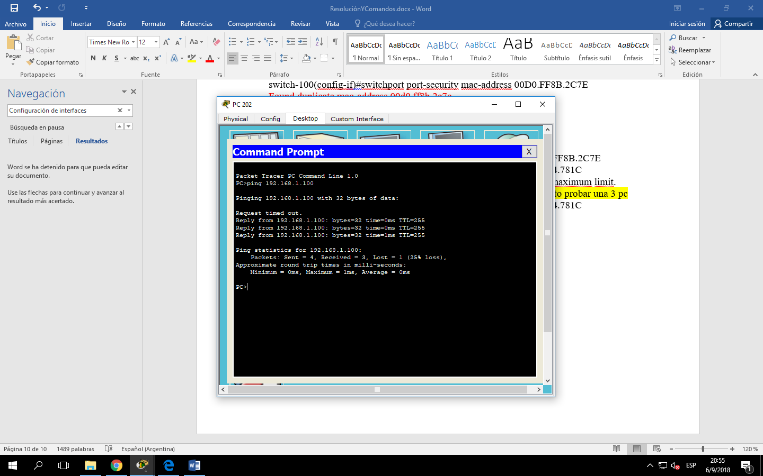

1. Creo dos VLANs.
2. Para que se puedan ver entre ambas, debe ser a través del router (trunk)

Tengo tantos dominios de colision por bocas de Switchs

Tengo tantos dominios por broadcast por router

Primero tengo que crear la VLAN y después asignar los puertos

1. Voy a crear las VLANs 10 (101) y 20 (102) en SW1 => Una para cada PC. Los puertos se ponen en modo ACCESS
2. Voy a crear las VLANs 10 (201) y 20 (202) en SW2=> Una para cada PC. Los puertos se ponen en modo ACCESS
3. Si no creo las vlans en el switch superior, no se van a ver. Para que se puedan ver deben tener creadas (por lo menos) las VLANs, no hace falta asignar los puertos. En caso de asignarlos, los puertos deben estar en modo TRUNK (puertos que permite el pasaje de trama entre vlans)

**SEGUNDA PARTE - CONFIGURACIÓN DE SWITCHES DE DISTRIBUCIÓN Y NÚCLEO**

En la sala de distribución principal, MDF, se han conectado los switches de distribución mediante dos interfaces de 1Gb de FO al switch de núcleo y mediante otra interfaz entre sí, formando loops de capa 2 a fin de asegurar la disponibilidad.

La configuración de spanning tree está por defecto en los tres switches.

**1. Identificación del switch RAÍZ y la configuración de puertos.**

1) Identifique el switch raíz. ¿Por qué ha sido seleccionado como tal?

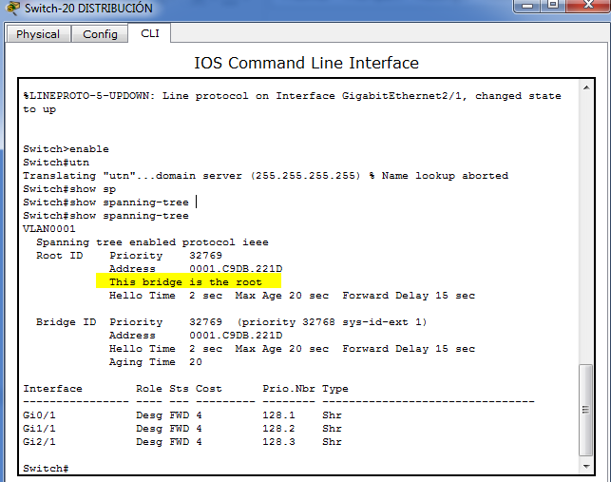

2) Identifique los puertos raíz, los puertos designados y los puertos bloqueados.

**2. Configuración de STP con agregado de enlace.**

1) Configure el switch de núcleo para que sea seleccionado como raíz.

*Switch1(config)# spanning-tree vlan* **1,10,20 root primary**

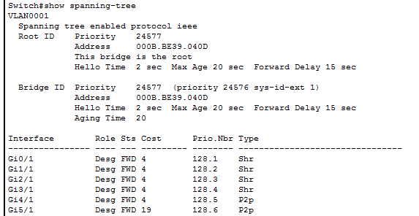

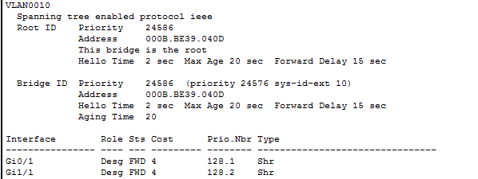

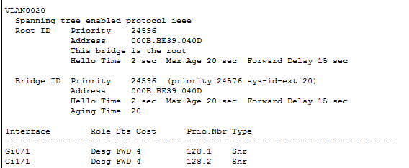

Quedó como ROOT de todas las VLANs: 1, 10 y 20. Ver mensaje “this bridge is the root”

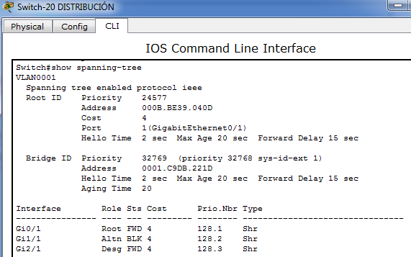

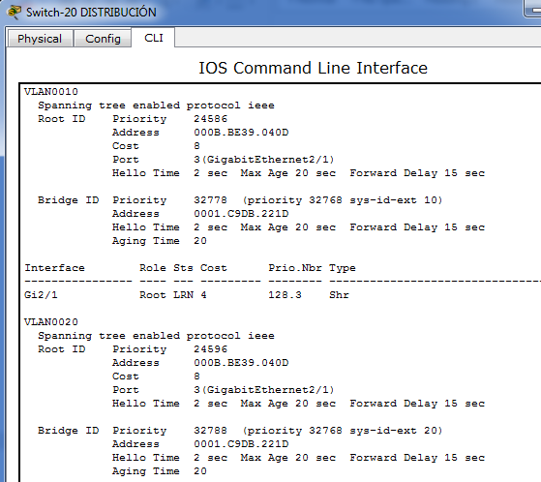

2) Configure agregado de enlace LACP entre los switches de distribución y el de núcleo, con el fin de duplicar el ancho de banda, evitando que *spanning tree* bloquee uno de ellos y aplicando correctamente los conceptos de dst-mac | src-mac para el balanceo de carga:

*Switch1(config)# port-channel load-balance* {dst-mac | src-mac}

-

*Switch1(config)# interface gigabitethernet* **1/1**

*Switch1(config-if)# switchport mode* **trunk**

*Switch1(config-if)# channel-protocol* **LACP**

*Switch1(config-if)# channel-group* **1** *mode active*

*Switch1(config-if)# exit*

<https://www.youtube.com/watch?v=Cgj0nlCys8s>

Cuando el tráfico viene del Router hacia el Switch Núcleo: una sola MAC de origen (Router) y muchas MAC de destino distintas (PCs), por lo cual se usa DST-MAC.

Cuando el tráfico viene desde las PC hacia el Switch Distribución: muchas MAC de origen distintas (PCS) y una sola de destino (el Router), por lo cual se usa SRC-MAC para aprovechar mejor los enlaces.

dst-mac—Load distribution on the destination MAC address   
src-mac—Load distribution on the source MAC addres

**NUCLEO**

**G0/1 y G1/1 => Switch 10- distribución (izquierda) => Group 1**

*Switch1(config)# port-channel load-balance dst-mac*

*Switch1(config)# interface g0/1*

*Switch1(config-if)# switchport mode* **trunk**

*Switch1(config-if)# channel-protocol* **LACP**

*Switch1(config-if)# channel-group* **1** *mode active*

*Switch1(config-if)# exit*

*Switch1(config)# interface g1/1*

*Switch1(config-if)# switchport mode* **trunk**

*Switch1(config-if)# channel-protocol* **LACP**

*Switch1(config-if)# channel-group* **1** *mode active*

*Switch1(config-if)# exit*

**G2/1 y G3/1 => Switch 20- distribución (derecha) => Group 2**

*Switch1(config)# interface g2/1*

*Switch1(config-if)# switchport mode* **trunk**

*Switch1(config-if)# channel-protocol* **LACP**

*Switch1(config-if)# channel-group* **2** *mode active*

*Switch1(config-if)# exit*

*Switch1(config)# interface g3/1*

*Switch1(config-if)# switchport mode* **trunk**

*Switch1(config-if)# channel-protocol* **LACP**

*Switch1(config-if)# channel-group* **2** *mode active*

*Switch1(config-if)# exit*

**SWITCH 10 – DISTRIBUCION**

*Switch1(config)# port-channel load-balance src-mac*

**G0/1 y G1/1 => Switch NUCLEO => Group 1**

*Switch1(config)# interface g0/1*

*Switch1(config-if)# switchport mode* **trunk**

*Switch1(config-if)# channel-protocol* **LACP**

*Switch1(config-if)# channel-group* **1** *mode active*

*Switch1(config-if)# exit*

*Switch1(config)# interface g1/1*

*Switch1(config-if)# switchport mode* **trunk**

*Switch1(config-if)# channel-protocol* **LACP**

*Switch1(config-if)# channel-group* **1** *mode active*

*Switch1(config-if)# exit*

**SWITCH 20 – DISTRIBUCION**

*Switch1(config)# port-channel load-balance src-mac*

**G0/1 y G1/1 => Switch NUCLEO => Group 2**

*Switch1(config)# interface g0/1*

*Switch1(config-if)# switchport mode* **trunk**

*Switch1(config-if)# channel-protocol* **LACP**

*Switch1(config-if)# channel-group* **2** *mode active*

*Switch1(config-if)# exit*

*Switch1(config)# interface g1/1*

*Switch1(config-if)# switchport mode* **trunk**

*Switch1(config-if)# channel-protocol* **LACP**

*Switch1(config-if)# channel-group* **2** *mode active*

*Switch1(config-if)# exit*

